Open New Outlook
Right Click on your email address down the left and select ‘Add public folder to Favourites’
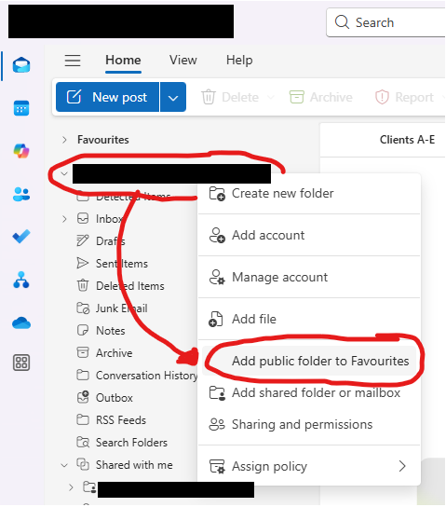
In the window that appears, expand the public folders then select the calendar(s) you want to add then click ‘Add Public Folder’
